Chapter 13, Problem 70.

In the ideal transformer circuit shown in Fig. 13.133, determine the average power delivered to the load.

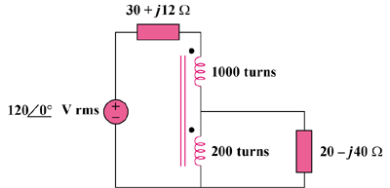

Figure 13.133
For Prob. 13.70.

